SMART WATER FOUNDATION

TEAM MEMBER

M.S. SANJAY 510421106041

Phase -3 Document submission

Project:SMART WATER FOUNDATION

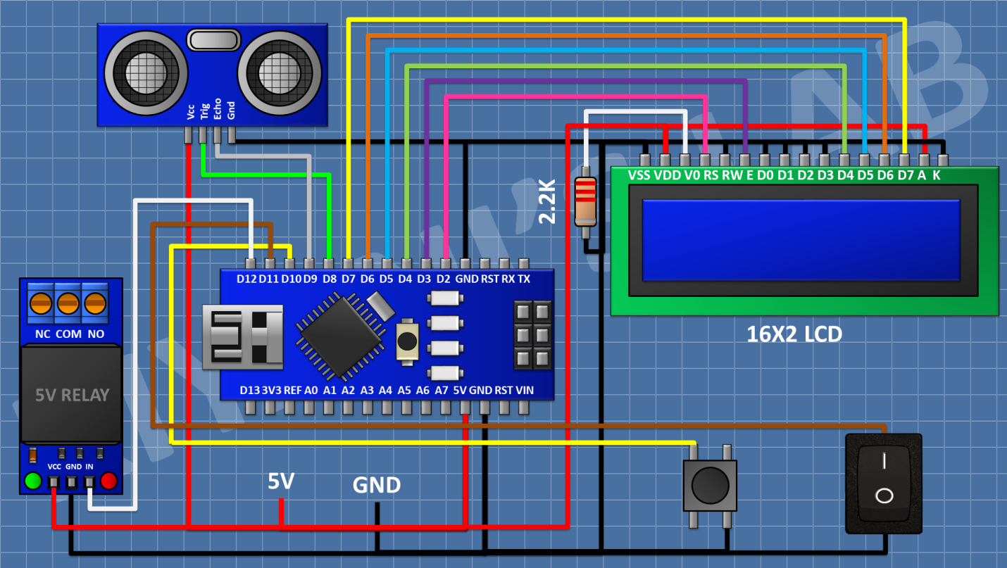**Ultrasonic sensors are commonly used in various water-related applications, including water level monitoring, flow measurement, and quality control. These sensors work by emitting high-frequency sound waves that bounce off objects and return to the sensor. By measuring the time it takes for the sound waves to return, ultrasonic sensors can determine the distance to the object, which is valuable in various water-related scenarios.**

**Water Level Monitoring:**

Ultrasonic sensors can be used to measure the water level in tanks, reservoirs, rivers, and other bodies of water. They are often employed in industrial and environmental monitoring systems to ensure that water levels are within desired limits.

**Flow Measurement:**

Ultrasonic sensors can be used to measure the flow rate of water in pipes and open channels. By installing sensors at specific points along the water course, you can calculate flow rates and monitor water consumption.

**Water Quality Monitoring:**

While ultrasonic sensors are not typically used for direct water quality assessment, they can play a role in some monitoring systems. For example, they can help monitor the water level in sedimentation tanks or wastewater treatment processes.

**Flood Detection and Warning Systems:**

Ultrasonic sensors can be part of flood detection and warning systems. They can monitor water levels in rivers and trigger alarms or alerts when water levels rise above a certain threshold, helping to mitigate flood risks.

It's possible that a "Smart Water Foundation" or similar organization may be working on projects related to the application of ultrasonic sensors in water-related projects. If you have specific information about this foundation or need more detailed information, I would recommend searching for the latest updates or contacting the organization directly if it exists beyond my last knowledge update in January 2022.

**Program:**

import machine

import time

# Pin assignments for the ultrasonic sensor

TRIGGER_PIN = 23 # GPIO23 for trigger

ECHO_PIN = 22 # GPIO22 for echo

# Pin assignment for the LED

LEAK_LED_PIN = 19 # GPIO19 for the LED

# Set the pin modes

trigger = machine.Pin(TRIGGER_PIN, machine.Pin.OUT)

echo = machine.Pin(ECHO_PIN, machine.Pin.IN)

leak_led = machine.Pin(LEAK_LED_PIN, machine.Pin.OUT)

# Function to measure distance using the ultrasonic sensor

def measure_distance():

# Generate a short trigger pulse

trigger.value(0)

time.sleep_us(5)

trigger.value(1)

time.sleep_us(10)

trigger.value(0)

# Measure the echo pulse duration to calculate distance

pulse_start = pulse_end = 0

while echo.value() == 0:

pulse_start = time.ticks_us()

while echo.value() == 1:

pulse_end = time.ticks_us()

pulse_duration = pulse_end - pulse_start

# Calculate distance in centimeters (assuming the speed of sound is 343 m/s)

distance = (pulse_duration * 0.0343) / 2 # Divide by 2 for one-way travel

return distance

# Function to check for a water leak

def check_for_leak():

# Measure the distance from the ultrasonic sensor

distance = measure_distance()

# Set the threshold distance for detecting a leak (adjust as needed)

threshold_distance = 10 # Adjust this value based on your tank setup

if distance < threshold_distance:

# If the distance is less than the threshold, a leak is detected

return True

else:

return False

# Main loop

while True:

if check_for_leak():

# Blink the LED to indicate a leak

leak_led.value(1) # LED ON

time.sleep(0.5)

leak_led.value(0) # LED OFF

time.sleep(0.5) else:

leak_led.value(0) # LED OFF

time.sleep(1) # Delay between measurements

**Conclusion:**

In conclusion, smart water fountains represent a promising fusion of technology and sustainability, offering a multitude of advantages for both users and the environment. These innovative fountains stand at the forefront of modernizing hydration experiences by harnessing advanced technologies to provide clean, safe, and efficient access to drinking water.